Matthew Oliphant

CS 319: UI/ UX Design & Development

Southern New Hampshire University

July 25, 2021

**Wireframe Designs**

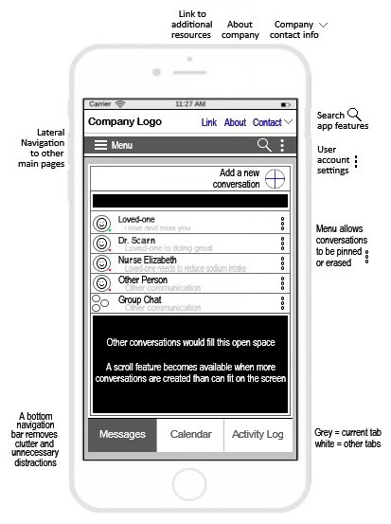

Wireframe #1

Caretaker UI displaying the messages section of the app

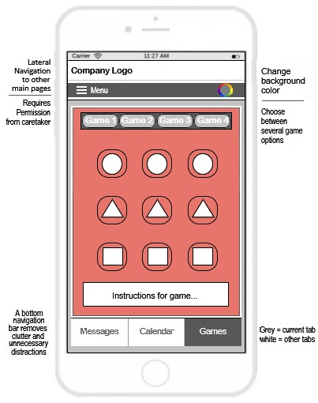

Wireframe #2

Elderly UI displaying the games section of the app

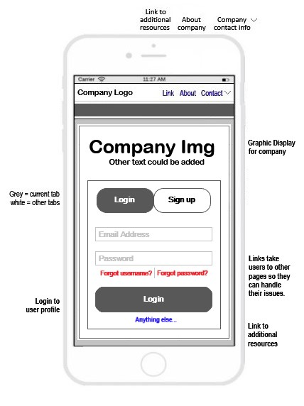

Wireframe #3

UI for both users displaying the login/ signup page for the app